2024 MOTORSPORT AUSTRALIA
NSW PRODUCTION TOURING CAR CHAMPIONSHIP

H1 ELIGIBILITY

- The objective for the 2024 Motorsport Australia NSW Production Touring Car Championship (‘Championship’) shall be to provide a competitive and exciting racing category for production-based Type 3E vehicles. All drivers must be Registered in the 2024 Production Touring Car Championship to participate in any on track activities including qualifying, warm up sessions or races.

- The series of races is open to all drivers who hold the minimum of a Motorsport Australia Provisional Circuit Licence, except for any event conducted at Mt Panorama Bathurst where each driver must hold a current Motorsport Australia Circuit Licence or higher, and whose vehicles comply with Series Production Touring Cars as defined in 2024 Motorsport Australia Group 3E Regulations

- The Championship is run under the control of the Motorsport Australia (‘Motorsport Australia’), competitors must ensure that their vehicle complies with either Group 3E, eligibility approval process or any additional Motorsport Australia directives including any additional freedoms as stated in this Appendix.

- Where recognition documents for a particular vehicle are not available, other vehicles will be considered upon application to the Committee. Each vehicle competing in the Championship shall be registered with the NSW Production Touring Cars INC (‘Organisers’).

- The onus of proof of vehicle eligibility rests with the individual competitor at all times. All competitors are to submit a Vehicle Compliance Form. Forms are at Attachment B to these regulations. The completed and signed form is to submitted to the Category Technical Manager prior to competing in their first event of the year.

- Motorsport Australia Bulletins/Directives, Group 3E Rules, Motorsport Australia Group 3E recognition documents, FIA Homologation documents and the Vehicles’ Workshop Manuals must be made available by the competitor to the Category Technical Committee at their request. The list in this paragraph sets the order of precedence for documents to be referenced.

- At the conclusion of any session, any vehicle may be directed to parc fermé without returning to the pits or paddock area and without having been interfered with. Such vehicles shall remain under the control of the Chief Scrutineer, an Official appointed by him or the Eligibility Officer. The Organisers reserve the right to require any competitor to remove components, at the competitor’s cost, to confirm the component's compliance with the requirements with Attachment A Regulations and the eligibility requirements of this Championship.

- Any competing car may be impounded at the discretion of the Chief Scrutineer or the Eligibility Officer in accordance with the Circuit Race Standing Regulations.

- The Eligibility Officer for the Championship shall be TBA, and the Eligibility Assistant for the Championship shall be TBA and the Organisers’ Technical Committee.

- Each vehicle must remain in compliance with all aspects of Group 3E, Motorsport Australia Recognition document or Motorsport Australia directives, except for the freedoms or limitations permitted by these Regulations; any modification or tuning practice which is not specifically permitted by these Regulations is expressly forbidden.

- Following the commencement of the first official practice/qualifying session of each round of the Championship, any vehicle that has been entered to compete at that round may not be replaced with another vehicle. To receive championship points drivers must compete in the vehicle they qualify in which has been entered to compete at that round of the Championship.

- Tyres

  - Each vehicle must be fitted with the Yokohama A050 control tyre in Medium compound as per the Contractual Agreement, of a size appropriate for their vehicle, and purchased from the control tyre supplier. Vehicles not fitted with the Yokohama control tyre purchased from the control tyre supplier will not be allowed to partake in any session of practice or competition. Where a suitable tyre is not available from the control tyre supplier, this needs to be confirmed in writing from the control tyre supplier and approval obtained from the technical committee to run a specified alternative tyre.

  - Each tyre must be purchased from the Control Tyre Supplier listed below.

Gordon Levin Motorsport Tyres
6/133 Russell St
Emu Plains NSW
Contact: Phil
Ph: (02) 4735 8734
M: 0407 354 500
Email: phill@gordonleven.com.au

  - The use of any tyre heating, heat retention devices or chemical treatments are prohibited. With the exception of wear resulting from normal usage, all tyres must remain unmodified. Heat cycling new tyres by the tyre provider is permitted prior to any use of the tyre.

  - At no time may any tread wear indicator be exposed, or in the case of tyres that have dimpled tyre wear indicators, the tyre must not be worn below the indicator. With the exception of the shoulder of a tyre, in each area of a tyre where there is no tread wear indicator, the original tread pattern must be clearly visible.

Please Note: The Eligibility Officer is the sole arbiters with regard to the interpretation and application of these Tyre Regulations and any decision made by the Eligibility Officer in this regard will not be the subject of any protest or appeal.

- Forced Induction Cars

  - In accordance with Motorsport Australia Specifications of Vehicles Motorsport Australia Group 3E Item 4.14, all cars which have forced induction engines must be fitted with an MSE BM2012 pressure monitoring data logger manufactured by:

Motor Sport Electronics
22 Deep Pool Way
MT ANNAN NSW 2567
Phone: (02) 4648 0030.
Email: sales@msedata.com.au
Mobile: 0402 102 553
Website: www.msedata.com.au
No MSE units manufactured before 1 January 2012 will be permitted.

  - For all forced induction vehicles, the maximum allowable inlet manifold pressure is as specified in the Motorsport Australia Group 3E Regulations (or any additional directives by Motorsport Australia), Motorsport Australia Recognition document, FIA Homologation document. The list in this paragraph indicates the order of precedence for documents to be referenced. If the above documentation does not list a maximum allowable inlet manifold pressure, then the figure listed in the Group 3E Class Structure & Automobile Eligibility List 2024, document will be used: See Attachment A.

  - The Organisers, Chief Scrutineer or Eligibility Officer has the right to check the output of the MSE Pressure Monitoring Data Logger at any time during a race meeting. The Eligibility Officer may exchange the competitor’s MSE unit for one owned by NSW Production Touring Cars INC at any time.

  - Each Pressure Monitoring Data Logger must be installed in the engine bay of the vehicle in accordance with all instructions issued by the Chief Scrutineer or Eligibility Officer and must remain fully operational to record the inlet manifold pressure of the vehicle for the duration of all practice sessions, qualifying sessions and races. No driver-controlled boost adjusters are permitted.

  - If any Automobile’s Boost Monitor is found by the Chief Scrutineer or Eligibility Officer to have recorded no data, corrupted data, incomplete data, uninterpretable data or manifold boost pressure (determined as described
in Attachment A) over the maximum allowable for that Automobile during a qualifying session or the race, the following actions will be taken:

    - If the recordings boost pressure is less than 5% above the maximum allowable for that vehicle, the Chief Scrutineer or Eligibility Officer may issue a warning to the competitor. A maximum of three (3) warnings, none of which may be for consecutive sessions (qualifying or race) may be issued for one vehicle in the Championship Year. If all warnings have been used, then the competitor will be excluded from any future races or qualifying sessions where the recordings boost pressure is above the maximum allowable for that vehicle.

    - If the recordings boost pressure is more than 5% above the maximum allowable for that vehicle, or the MSE Pressure Monitoring Data Logger was found to be not recording any data, request from the Stewards that the Competitor be disqualified from the session where the recordings were taken (race or qualifying) and will commence the next race from the rear of the grid. Should more than one vehicle be involved, the vehicles will be grid positioned at the rear of the field in accordance with their qualifying times. Any points earned in that session will be forfeited.

    - Further penalties may be imposed by the Stewards.

The Chief Scrutineer or Eligibility Officer may request access at any time to any other data being recorded by any device within the Automobile, for example a “MoTec Device”.

  - The Chief Scrutineer or Eligibility Officer are the sole arbiters with regard to the interpretation of any data recorded by the Boost Monitor and the determination of compliance of each vehicle with the maximum manifold pressure listed in the vehicle’s Motorsport Australia Recognition Document, or any additional directives from Motorsport Australia, or the figure listed in the Group 3E Class Structure & Automobile Eligibility List 2024, document. Any decision made by the Chief Scrutineer or Eligibility Officer in this regard shall not be the subject of any protest or appeal.

- Fuel – Only 98 Octane or Diesel Pump Fuel as detailed in Paragraph 2.1 of Schedule G of the Motorsport Australia Manual of Motor Sport shall be used for the duration of the meeting. With the exception of ambient atmospheric air and the specified fuel, no other substance may be added to the intake charge of the engine. The fuel may be randomly tested using the NSW Production Touring Digitron Fuel Tester.

- Fuel Sampling – A dry break fuel sampling coupling at the fuel rail is mandatory. The approved dry break fuel sampling coupling is the Goodridge G-Link quick disconnect coupling (Part number, GQD08PP06F), which can be purchased from Competition Friction 02 6226 8877. The competitor is responsible for ensuring that this fitting is fitted to the vehicle.

Fuel samples may be taken during parc ferme. When directed to supply a fuel sample the vehicle is not permitted to be moved or started from that point until the fuel sample is taken and the results confirmed. The Fuel Testing team is deemed to be a Judge of Fact.

- The Driving Standards Advisor (DSA) for the Championship shall be Bevan Tanner.

- Camera – All vehicles must have an operating video camera mounted showing a clear view of the driver and track to the front of the car. The video camera must be mounted, operating and recording during every session. The DSA can request any video camera footage at any time. Penalties will be determined after referral to the Clerk of Course and may include exclusion from the session for non-provision of camera footage of that session to the DSA. If a vehicle is found to not have a camera fitted, then all points for the preceding session will be forfitted.

H2 CLASS DEFINITION

- For the Championship the following vehicle classes shall apply:

1. Class X Ultimate Performance
2. Class A1 High Performance Turbo
3. Class A2 High Performance Naturally Aspirated
4. Class B1 Performance Turbo
5. Class B2 Performance Naturally Aspirated
6. Class C Sports Touring Cars
7. Class D Other Touring Cars
8. Class E Small Capacity Touring Cars

- All vehicles competing in the Championship must be models that are included in the 3E Production Car Group 3E Class Structure & Automobile Eligibility List 2024, , which is published by the 3E National Management Committee from time to time.

- Only those vehicles currently listed in the Group 3E Class Structure & Automobile Eligibility List 2024, may compete within the Production Touring Car category. Any new additions to the Group 3E Class Structure & Automobile Eligibility List 2024 , need to be referred to the 3E National Management Committee. The Group 3E Class Structure & Automobile Eligibility List 2024 is for Motorsport Australia Group 3E Series Production Cars as defined in Motorsport Australia Group 3E.

- Competitors are advised to contact the Technical Committee for clarification of any issues relating to eligibility of vehicles or class definitions prior to purchasing or building a car for entry to this Championship. The Eligibility Officer for the Championship is TBA who can be contacted on mobile: TBA or email

- All cars must display classes on the upper left of the front windscreen and adjacent to the door racing numbers on both sides of the vehicle. The size of the class stickers will be a minimum of 150mm in height and the colour must be dayglo yellow or green.

H3 REGISTRATION

- To be eligible to compete and to score points detailed in Section H10 at any round of the Championship, the registration fee described in Section H3(ii) must be received by the Organisers before the commencement of qualifying at that race meeting.

- The registration fee shall be $200.00 for the year and includes membership of the NSW Production Touring Cars INC.

H4 CATEGORY ORGANISERS

- The Organisers of the Championship shall be the NSW Production Touring Cars INC, herein referred to as ‘Organisers’.

The Championship Director, Dave Shylan, who can be contacted on mobile:
0417 204 030 and the Club Secretary, Brent Howard, who can be contacted on mobile: 0401 710 645 for administrative matters.

- The Organisers' website is www.nswproductiontouringcars.com.au

H5 RACES

- The State Championship will consist of five (5) Rounds.
- The Qld event on the 6/7/8 September will only be a club championship points score round as well as part of the Qld V NSW State of Origin.

- State & Club Championship Calendar.
Round | Date | Circuit | Race Format
1 | 27/28 April | Winton Raceway | Double Enduro
2 | 25/26 May | Sydney Motorsport Park (GP) | Sprint
3 | 22 June | Sydney Motorsport Park (GP) | Sprint D/N
4 | 3/4 August (TBC) | Sydney Motorsport Park (GP) | Sprint
5 | ** 6/7/8 September** | Morgan Park Raceway | Double Enduro
6 | 28/29 September | Sydney Motorsport Park (GP) | Enduro

- Unless otherwise approved by Motorsport Australia, each round of the Championship shall comprise one of the following race formats:

  - “SPRINT” – More than three (3) sprint races of a planned minimum of 10 minutes duration each which may be expressed as a number of laps appropriate to the host circuit in the Supplementary Regulations of the event, OR

  - “SPRINT” – Up to two (2) sprint races of a planned minimum of 20 minutes duration each where each race may be expressed as a number of laps appropriate to the host circuit in the Supplementary Regulations of the event, OR

  - “ENDURO” – One (1) sprint race of a planned minimum of 12 minutes duration, one (1) co-driver’s sprint race of a minimum of 12 minutes duration and one (1) Enduro of not less than 45 minutes duration which may be expressed as a number of laps appropriate to the host circuit in the supplementary regulations.

  - “DOUBLE ENDURO” – Two Enduro of 60 minutes duration.

- For ENDURO race meetings, there can be one (1 / Sole Driver) or two (2 / Driver A & Driver B) drivers entered for each vehicle. In the event of two (2) drivers being entered, the first shall be Driver A and the second shall be the co-driver (Driver B). The second sprint race (only run if there are co- drivers), may be contested by both co-drivers and sole drivers but shall count toward the points score referred to in Section H7 for the co-driver only (Driver B).

- Where there are (1 / Sole Driver) or two (2 / Driver A & Driver B) drivers entered for each vehicle the Event Organiser is to provide helmet stickers to identify Driver A, Driver B and Sole Drivers (S).

- For ENDURO race meetings, the Enduro race shall include a Compulsory Pit Stop (Refer to Section H9 Compulsory Pit Stops).

H6 QUALIFYING

- Unless otherwise approved by Motorsport Australia, qualifying shall consist of one (1) session of approximately 15 minutes duration for SPRINT race meetings, or two (2) sessions of approximately 15 minutes for ENDURO race meetings. Where there are two qualify sessions, they are to be separated by at least 2 other sessions.

- Unless otherwise approved by Motorsport Australia, qualifying for Double ENDURO race meetings shall consist of two x 20 minute qualifying sessions.

- Where there are two (2) qualifying sessions, one (1) of these shall be for the drivers (Driver A and Sole Drivers) and one (1) session for the co-drivers (Driver B). Sole Drivers are able to participate in the Driver B qualifying session if they wish (not compulsory) however their qualifying time for the ENDURO will be taken from the Driver A session only.

- Where entries are over 75% of grid capacity, in consultation with the promotor, there will be a split qualifying consisting of –

  - Session 1: 50% of cars or as close as possible split by class (e.g., Classes A1, A2 and B1)

  - Session 2: Remaining cars

H7 GRID POSITIONS

- For SPRINT race meetings, grid positions for Race 1 will be allocated according to the fastest lap time achieved by each driver in qualifying. The fastest driver will be allocated position 1 and thereafter successive positions will be allocated in order of increasing lap time. For successive races, the starting position shall be in accordance with the finishing position in the previous race except for any penalty that may be applied that results from a breach of this Appendix, or any other penalty applied by the Stewards of the Meeting.

- For ENDURO meetings the grid positions for each of the races shall be in accordance with the fastest lap time achieved in qualifying by the driver that is starting that race, except for any penalty that may be applied that results from a breach of this appendix, or any other penalty applied by the Stewards of the Meeting. Also see (v) Top Ten shootout below.

In the case of two (2) drivers competing in one vehicle in an ENDURO, Driver A and Sole Drivers must qualify and race in Driver A sessions, and Driver B must qualify and race in Driver B sessions. A Sole Driver can enter Driver B qualifying and can race in the Driver B race based on their Driver B qualifying time. and they will not receive Championship points from the Driver B races. However, the Sole Driver qualifying time for the enduro race will be taken from the Driver A qualifying session only.

Championship points will be awarded to Driver B drivers as if Driver A drivers were not present in the race. Driver B race grid will be determined on qualifying times of all cars entered in that race.

- For DOUBLE ENDURO meetings the grid position for each of the races shall be in accordance with the fastest lap time achieved in qualifying by the driver that is starting that race, except for any penalty that may be applied that results from a breach of this Appendix, or any other penalty applied by the Stewards of the Meeting. Note: The grids for the two (2) ENDURO races are NOT progressive but based on the qualifying time for the nominated starting driver for each race.

- Starting Driver Nomination for each round:

  - All two (2) driver teams must nominate starting driver for the ENDURO races, by notifying the Secretary of the Event or nominated person no later than three (3) hours after the finishing time for their final qualifying session. If a nomination is not received by the nominated time, then the Driver A will be the starting driver for all ENDURO races.

  - Nominations are not required for the Driver A or Driver B races.

  - The Event organisers are to ensure the Starting Driver Nominations process is provided to each entrant at sign on. Also, they are to ensure that the deadline for nominations is announced during the nomination period. Note: If the event is a Double Enduro the starting driver could be different for each race.

  - On registering their starting driver nomination, the Event Organisers are to supply the Starting Driver with an appropriate helmet sticker to identify the starting driver. Note: If the event is a Double Enduro the starting driver could be different for each race.

- Top Ten shootout:

  - A top ten shoot-out may be held based on the 10 fastest cars from qualifying. The qualifying times from the Top 10 Shoot-Out will determine the top ten positions for the race grid.

  - Competitors not in the Top 10 Shoot-Out will be placed behind the competitors who took part, in their original order of qualifying times from the original qualifying session.

H8 STARTING PROCEDURE

- The starting procedure for all races shall be in accordance with Item 2.9 of the 2024 Motor Race Championship Sporting Regulations and Motorsport Australia Race Meeting Standing Regulations.

- For the purpose of measurement, the race time for an Enduro shall commence when the starting lights are extinguished, or the starting flag is lowered by the race starter.

H9 COMPULSORY PIT STOPS

- Compulsory Pit Stops (CPS) shall be a 60 seconds stationary stop, during which a driver change can be conducted.

- Each CPS shall be conducted in accordance with the following:

  - Where a stationary time is specified above the car MUST remain stationary for the required time. The validation of the stationary time will be through using the circuit timing system using the pit lane transit time plus 60 seconds.

Wakefield Park – Pit lane transit time is 32 Seconds
Sydney Motorsport Park – Pit lane transit time is 33 Seconds
Winton Raceway - Pit lane transit time is ???? Seconds

  - Driver Change (2 drivers)
- Exiting Driver – removes themselves from vehicle
- Entering Driver – assumes driving position, attaches seat belts, before the vehicle may proceed at the direction of the car controller;
- During this change, the drivers are allowed to assist each other with any adjustments deemed necessary.

  - Driver Change (1 driver)
- For each vehicle with a single driver, the driver may remain seated in the car.

- On completion, a Pit Observer will then log the time of execution of the CPS and success or otherwise of CPS and advise the Clerk of the Course of any infringements. Any infringements for failing to correctly execute a CPS in accordance with these rules will result in a one (1) lap penalty, or as determined by the Stewards.

- Failure to complete the CPS during the proscribed window will result in a three (3) lap penalty. Commencing a CPS during a safety car period will result in a three (3) lap penalty.

- Failure to attempt CPS at any time during the race will result in a five (5) lap penalty.

- Each vehicle must complete one (1) CPS during the prescribed pit stop window in the race. A CPS may only be conducted when pit ‘window’ is open.

- For one (1) hour races, the CPS window shall open when 10 minutes of the race has been completed and close when 50 minutes of the race has been completed. For 50 minute races the CPS window shall open when 10 minutes of the race has been completed and close when 40 minutes of the race has been completed.

NOTE – If the safety car is out during CPS ‘Window’ the window will not be extended, all laps under the safety car count. The pit lane is only open for its prescribed time, whether the safety car is out controlling the race or in the pits.

- There will be a board displayed at the start/finish lane entrance to advise that the window is open-closed. This board will be displayed for two (2) laps only when opening pit lane – and two (2) laps only on closing pit lane for the purposes of a CPS.

- A CPS cannot commence during a safety car period. If a vehicle is already in pit lane then the vehicle can complete its CPS.

- There will be no refuelling during the CPS, any discretionary pit stops, or any other time during the race. The penalty (as imposed by the stewards) for any refuelling during any pit stop could lead to exclusion from that race.

- A vehicle shall be deemed to have commenced a CPS when the vehicle enters pit lane (crosses the timing control line at pit entry).

- A vehicle shall be deemed to have completed a pit stop when the vehicle exits the pit lane (crosses the timing control line at pit exit).

- A Car Controller must be appointed for each vehicle who is responsible for the safe conduct of any pit stop and specifically for the safe release of the vehicle at the conclusion of the pit stop. At all times the Car Controller must remain at the front of the vehicle and is not permitted to perform work of any kind on a vehicle during a pit stop.

- A maximum of two (2) pit crew members, not including the Car Controller, are permitted to attend the vehicle during the CPS.

- Should a driver change be performed, the in-coming and out-going drivers will not be deemed a pit crew member and neither driver is permitted to perform work of any kind on the vehicle during the CPS, however, the drivers may assist each other to exit and enter the vehicle. Alternatively, a Driver’s Assistant may be used to assist with a driver change or a single driver exiting and re-entering the vehicle in addition to the two (2) pit crew members, but this is the only function the assistant may carry out during the CPS. The in-coming and out-going drivers may remove or replace a drink bottle.

- Each vehicle must come to a complete stop in its allocated pit bay prior to the safety harness being unfastened.

- All crew, except the car controller, and equipment must remain behind the prescribed control line until the vehicle has come to a complete stop in its allocated pit bay.

- The Car Controller may only cross the prescribed line into pit lane one (1) lap prior to the pit stop.

- The safety harness must be fastened before the vehicle leaves its allocated pit bay.

- All crew and equipment must return behind the prescribed control line, except the car controller, before the vehicle can leave its allocated pit bay.

- The Car Controller must be behind the prescribed line before the vehicle exits the pit lane.

- Each vehicle with more than one driver shall have each driver’s helmet marked with an ID decal as supplied by the organisers. This decal must be placed on the right-hand side of the helmet for right hand drive cars.

- If a vehicle takes more than twice the time of the winner’s fastest lap time in the race to complete the last lap of the race, this lap will not be taken into account when determining the total race distance covered.

- All time or lap penalties will be applied at the conclusion of each Enduro race.

H10 POINTSCORE

- Points shall be awarded to all drivers who meet the eligibility requirements of Section H1 and H3 for all races for each class as detailed in the following Table. To receive Championship Points drivers/entrants must exhibit their Club Registered Race Number on the vehicle they are competing in, unless they are competing in another vehicle where the driver/entrant is using their Club Registered Number (ENDURO). The number of cars for each class will be the number of eligible cars in that class that start each Race at each event:

SPRINT Races
Cars in  Class | 1st | 2nd | 3rd | 4th | 5th | 6th | 7th | 8th | 9th | 10th
6+ | 20 | 18 | 16 | 14 | 12 | 10 | 8 | 6 | 4 | 2
3-5 | 16 | 14 | 12 | 10 | 8
1-2 | 10 | 8

ENDURO Races
Cars in  Class | 1st | 2nd | 3rd | 4th | 5th | 6th | 7th | 8th | 9th | 10th
6+ | 40 | 36 | 32 | 28 | 24 | 20 | 16 | 12 | 8 | 4
3-5 | 32 | 28 | 24 | 20 | 16
1-2 | 20 | 16

- All five (5) rounds shall count towards the final point score for the Championship.

- Points awarded to each Driver after each round will be aggregated to the points obtained by each Driver during previous rounds as the Championship proceeds. The 2024 NSW Production Touring Car Championship will be a Five (5) round Championship. The winning Driver of the 2024 Championship will then be the Driver with the highest accumulated points after the last round.

- A driver can score points in different vehicles at different meetings during the year. Points will be awarded according to Section H10(i) for the class in which the individual vehicle falls.

- For Enduro races in which a vehicle entered has both a Driver and Co-Driver, both Driver and Co- Driver are eligible to score points as detailed in Section H10(i). For the Co-driver race the number of cars will be based on the number of co-drivers only.
- Prior to release of the pointscore for each round the DSA and Eligibility Officer are to review the pointscore to ensure that any pointscore penalties have been applied.

- The outright Drivers’ Championship will be awarded to the driver who accumulates the most points over the five (5) rounds. Should a driver earn points in more than one class during the year, the points earned in each class will be added together to give a total driver’s point score.

- If at the end of the year there is a tie on placings in the outright Championship, awards shall be determined by comparison of the number of first placings gained at each round. If then not resolved, comparison of the number of second placings, then third placings etc. Then if after all comparisons are affected and the award is still not determined, the relative placings in the last round, second last round, etc shall be the decider.

- In the event of a tie in any placing within a class at each round, the tie shall be split, and the higher placing shall be the competitor that attained the highest place in the trophy race.

H11 AWARDS

- Awards for 1st, 2nd and 3rd outright in the Championship shall be presented at the Motorsport Australia NSW Presentation Dinner. The Organisers will have a separate trophy presentation for individual class awards at a time that they advise.

- Promoters trophies will be presented at the circuit for 1st in each class. These will be based on the results of the trophy race, nominally the last Production Touring race of the meeting. The trophies will be presented directly after the trophy race.

- The Organisers will in addition to the promoters trophies, provide trophies for each meeting for 1st, 2nd and 3rd in classes that have 4 or more starting drivers and 1st for single class car drivers.

- Additional awards may be included at the discretion of the Organisers.

H12 SPONSORS

- The sponsor of this Championship is TBD.

- Associate sponsors may be included at the discretion of the Organisers.

H13 COMPETITION NUMBERS

- The number ‘1’ shall be reserved for the sole use of the outright winner of the previous year's NSW State Championship.

- The number ‘2’ shall be reserved for the sole use of the outright winner of the previous year’s Endurance Cup Championship.

- Drivers may otherwise request a competition number from the Organisers.

- Any request for a change in competition number shall be made to the Organisers who maintain the register of competition numbers that is provided to the promoters of the race meetings.

H14 COMPULSORY VEHICLE SIGNAGE

- Drivers must display the following stickers to be eligible for points in the Championship:

- NSW Production Touring Cars
- QUEST Apartments
- Allworth Homes
- V-Sport
- Shockwave Signs
- Massel
- Speedcafe (TBC)
- All 4 Corners – Yokohama Tyres

- Required positions for the stickers are as shown in the diagram below.

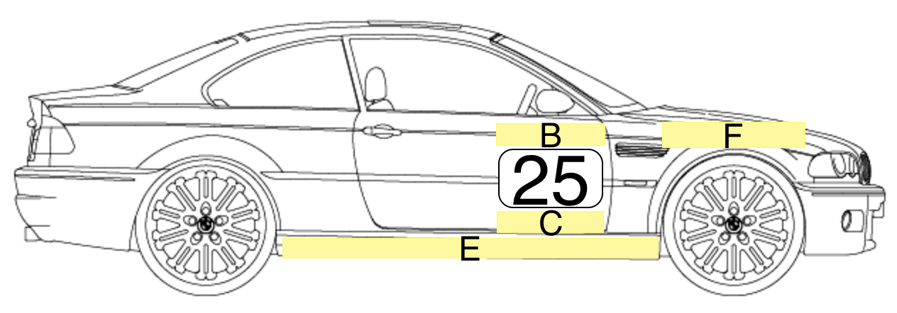
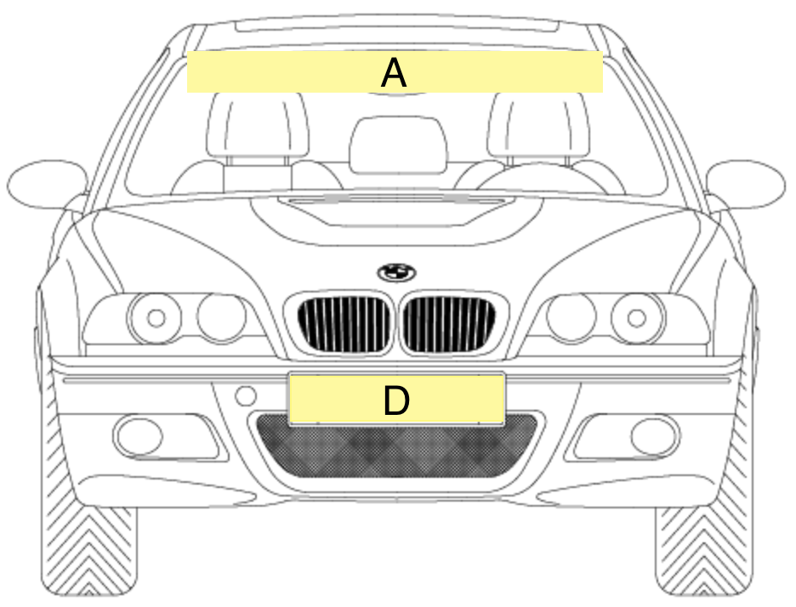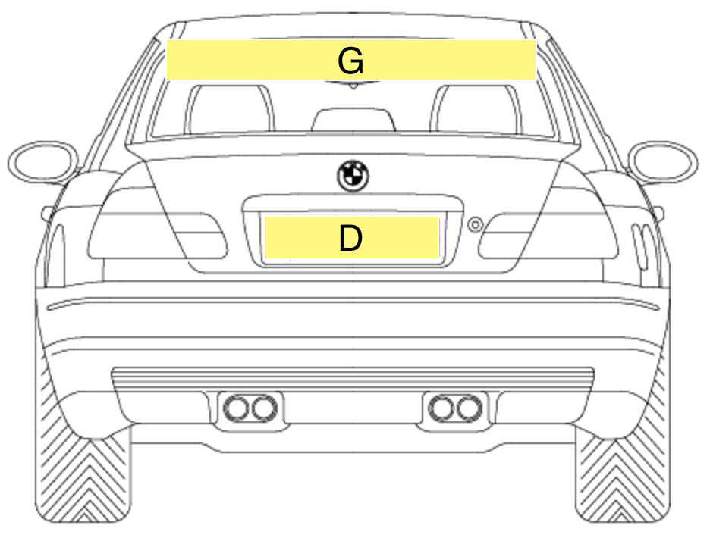

All stickers referred to above are available from the Organisers. A maximum of two sets of stickers per competitor will be issued free. Any additional stickers provided will be charged to the competitor at cost.

Attachment A: Group 3E Class Structure & Automobile Eligibility List 2024

Attachment B: Vehicle Compliance Form

Attachment B

NSW PRODUCTION TOURING
Vehicle Compliance Form – 2024

Competitor Name _______________________________NSWPTC Member Number __________

Vehicle Make ______________________________Model ___________________

Year _______ Variant ________________________ Vehcile Race Number __________

Recognition Doc #______________________

Engine – Was the engine:

New as delivered in Vehicle YES/NO

Second Hand replacement YES/NO

Rebuilt YES/NO

I understand that I should have a copy of my recognition document at all events.

I understand that my vehicle should be in compliance, at all times, with the Motorsport Australia Group 3E regulations and the recognition document noted above.

I understand that components of my vehicle may be checked and/or sealed and impounded for further checking at any time during an event. Any costs associated with removal or refitting a component will be at the competitor’s expense.

Signature ______________________

